Dimenson of the water system

We have already calculated the designing water demand. We have to define the great consumer. We consider a great consumer if it has 100 m³/day or more consumption. First we have to draw our one-loop main conduits line. There is a ring-mains on our area. The conduits must be laid down on the area of common use. We don’t lay it on the private area, and below the buildings. We have to divide this main ring into some parts, about 7-8 parts. These parts join with node. We set the nodes at the breakpoint (but it isn’ t necessary), and at the branch joint, and at the charging node. (1.1. Figure).

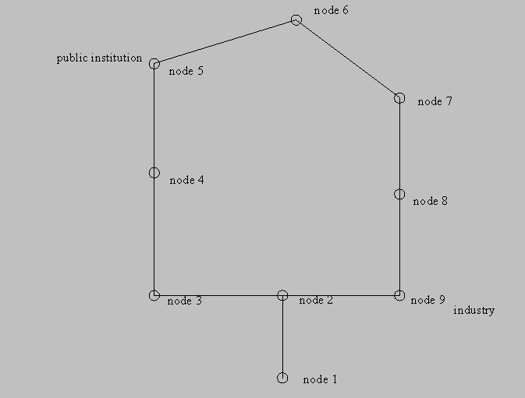

1.1. Figure: The one-loop main

We have to take on the nodes by every great consumer (for example the industrie, the public institution), because they have concentrated consumption in our modell. We consider the communal consumption an equipartition water consumption on our ring-mains. We have to burden this equipartition consumption upon the nodes. We carry out this distribution on the basis of conduits length or the area which belongs to the current node. We distribute the consumption according to the length in our example. You can see this calculating in the table 1.1..

1.1. table: Consumption of node

The water system has typical state, for example maximum and minimum consumption, fire event, burst in a water pipe. This event influences the behaviour of the water system. Every state has other pressure value and the flow quantity and the transporting direction. We design our system for the hourly peak demand. We multiply the daily people water demand by 8 per cent. That means the following The hourly consumption is 8 per cent of daily peak. We check our system in other states. The checking states are next:

- Minimum demand (1%)
- Average demand (4,17%)+ fire water

We have to compute the nodes consumption in these states (Table 1.2.).

1.2. Table: Consumption of node in the states

When we distributed the consumption upon the nodes we can modelling the ring-mains. We use the Kirchoff's lows (First and second).

First Kirchoff's law: The sum of the waters quantities, what flows in the node and out the node that is null.

Second Kirchoff's law: We take on a circuity direction in our ring-mean. The sums of the signed flow pressure loss is null along the ring-mean. The formula of flow pressure loss is in the next:

Where:

The „c” values, what belongs to different pipe diameter you can see on table 1.3..

1.3. Table: „c” value

First we calculate the nodes consumption. Than we take on a flow direction as we wish, but we have one regulation the first Kirchoff's law the low of node. So we get the flow quantity figure 1.2.. (We can make a branch from the ring, we cut a conduit between two nodes. So we can calculate the directions of the flows. The flow of the cut branch is null)

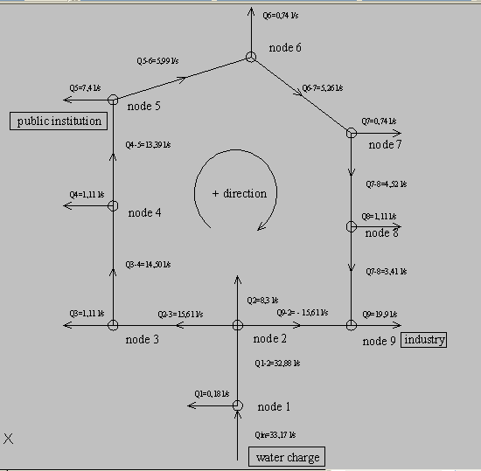

1.2. Figure: The beginning flow directions
We take on the diameter of conduits.

The diameter of each pipes can be calculated based on the maximum flow. We assume an optimal velocity of 1 m/s. We can calculate the diameters from the following expression, where only the D is unknown.

Q= v * D² * pi / 4

The minimum diameter is 100mm, and the fabricated diameter sizes are increasing with 25mm. We choose the closest value to the calculated one.

So we can calculate the flow pressure loss. We analyse our ring that is it adequate for the second Kirchoff's law. We define the failure of the sum of the pressure flow loss. Then we correct with dq all the pipes flows.

Dq= - ∑CQ² / ∑CQ

Then we calculate the flows pressure loss again, until the failure will null, this is the Cross method. Finally we get the right flow direction, and quantity. Than we check the ring, is it adequate for the pressure demand. We can get the pressure at the nodes, if we start from the connection node where the pressure is known, what is about 45-60 meter (4,5-6,0 bar) and we add the signed flow pressure loss on the path. The pressures must be higher as 20 meter or buildings height + 10 meter at the node. The water velocity must be about 0,5-1,50 m/s. The smallest allowed conduit is 100 mm in the water system. If the water system is not adequate for the pressure demand or water velocity, we have to change the conduit (diameter). We can see the cross method on table 1.4..

1.4. Table: The Cross-method

The solution of the calculation is showed by table 1.5.. We can see the right flow direction, the local flows pressure loss and the water velocity in the branches.

1.5. Table: The solution of calculation

We have to represent our solution on our system. We have to make a lettering, we have to write down on your branches:

- The right flow direction
- The water velocity or quantity of water flow
- The relative pressure at nodes
- The diameter of conduits

